Session 4 – Image Maps and Master Pages

Lab 01
Building Master Pages
With Visual Studio 2012, ASP.NET now supports visual page inheritance, which is similar to Windows Forms inheritance, for those who have used that popular framework. With ASP.NET 4.0, you can now create a single Master page that contains the common elements used by the pages of your site. You can then create web pages that inherit from the Master page to enforce a common look and feel across your entire site.
Using Master Pages to provide page headers is preferred over the use of Web User controls; only the Master page needs to be changed and the rest will follow!
In ASP.NET 4.0, a new feature known as Master Pages addresses the limitations of using Web User controls for headers and navigational menu information. In ASP.NET 4.0, you can simply construct a Master page that includes your page header information. You then build each page of your site by first inheriting from the site Master page.

To really understand how Master Pages work, you will build a web application using Master Pages in the next couple of labs. In this lab, you will create a Master page and populate it with some controls.
- In Visual Studio 2005, create a new ASP.NET 4.0 web application and name it s4-MasterPages.
- Add a folder named Images to the project (right-click the project name in Solution Explorer and select Add Folder→ Regular Folder). Copy the images in folder: .\Sessions\s4\Lab Resources\Lab 02\Images into the new s4-MasterPages\Images\ folder. You'll use these images to build your Master page.
- Now you'll create the Master page. Right-click the project name in Solution Explorer and then select Add New Item....
- In the Add New Item dialog, select the Master Page template and use the default name, MasterPage.master, as shown in Figure 2-2. Click Add to create the page.
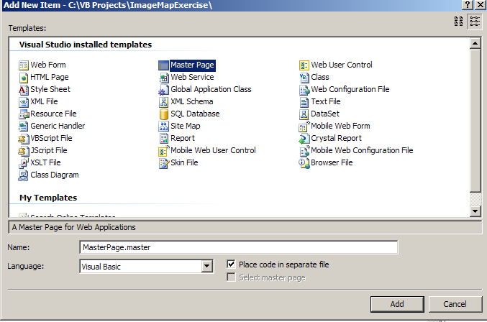
Figure 2-2: Adding a Master page to the project
- In Solution Explorer, double-click MasterPage.master and you will see an empty web page that contains a single ContentPlaceHolder control.
The ContentPlaceHolder control is a placeholder for Content pages (pages that inherit from the Master page) to populate with controls.
- Populate the MasterPage.master page with content, images, and links by dragging from the Toolbox and dropping onto its surface two Image controls, one Panel control, and four LinkButton controls, as shown in Figure 2-3. Set the properties of each of the controls as follows:

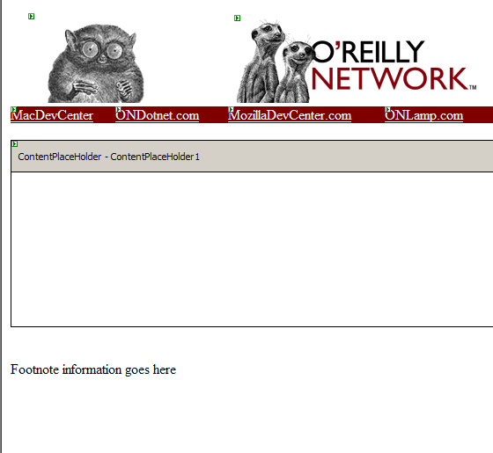
Panel control
LinkButton controls
Image controls
Figure 2-3: Populating the Master page
(NOTE place the controls above and outside the ContentPlaceHolder)
Image controls
Name the first Image control imgLogo and set its ImageURL property to Images/oreilly_header.gif to display the O'Reilly tarsier logo. Name the second Image control imgTitle and set its ImageURL property to Images/oranet_logo.jpg to display the O'Reilly Network logo.
Panel control
Use the mouse to stretch the Panel control across the page. Set its Backcolor property to Maroon.

LinkButton controls
Drop four LinkButton controls onto the Panel control. Name them as shown in Figure 2-3 (via their Text properties). As you are going to click on only one of the links, name the second LinkButton control lnkONDotnet. Set its PostbackUrl property to ONDotnet.aspx.
- Type in the footnote at the bottom of the screen, after the ContentPlaceHolder control. To type the footnote, position your cursor at the end of the ContentPlaceHolder control and press the Enter key. You can then start typing the copyright notice as shown below:
CRICOS Provider Name: Department of Further Education, Employment,
Science and Technology trading as TAFE SA | CRICOS No: 00092B
Date last modified: Monday 14 August 2006
That's it. Your Master page is now created. You will learn how to use it shortly

Lab 02
Use a Master Page as a Content Page Template
Using Master Pages and visual inheritance, you can give all your web site Content pages a common look and feel.
Once you've created a Master page, you can create Content pages for your site that use the Master page as a template.

How do I do that?
A Content page is a Web Form that uses a Master page.
In this lab, you will add Content pages to your project and give them a consistent look and feel by using the Master page you created in the previous lab. You will then add controls to a Content page and see how ASP.NET combines the content of the Master page and Content pages at runtime.
- First, let's create some pages for your web site. Using the project created in the previous lab, add a new Web Form. Right-click the project name in Solution Explorer and select Add New Item.... On the Add New Item page, select Web Form and use its default name (Default2.aspx). Check the "Select master page" checkbox at the bottom of the dialog (see Figure 2-6)
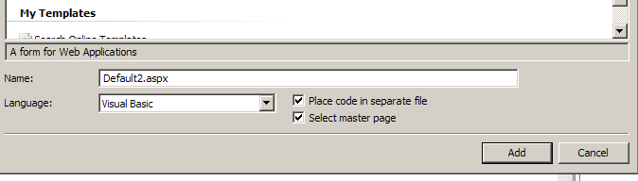
Visual C#
Figure 2-6: Selecting a Master page
You will be asked to choose a Master page to use for your form. Select MasterPage.master (see below)- A Content page can have only one Master page.
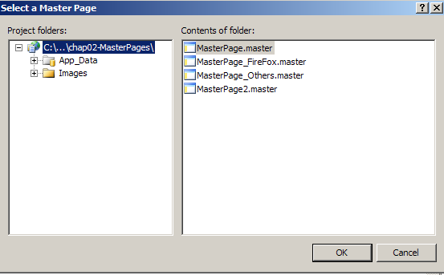

- Click OK and Visual Studio displays the new page, Default2.aspx, with the contents of the Master page grayed out (see Figure 2-8), indicating that the content of the Master page cannot be edited in the Default2.aspx form. Notice that the page is created with a Content control.
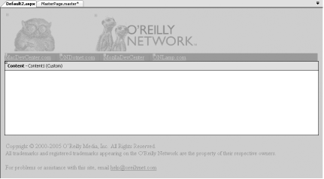
Figure 2-8: Populating the Content page

- You can customize the new page, Default2.aspx, by adding controls to the Content control. Note that you cannot modify the Master page in this page.
The Content control is the location where you populate the content of the page.
To edit the Master page, you can either right-click the Master page content and select Edit Master, or simply go to the Solution Explorer and double-click the Master page. Both actions will load the Master page for editing.
- To add content to the Content control, you can directly drag and drop controls onto it. You can also type directly into the Content control. Try adding some text to the Content control by opening the Default2.aspx page in Source mode and pasting the text copied from the Default.txt file located at: \Sessions\s4\Lab Resources\Lab 03 , between the <asp:Content> </asp:Content> Tags.
- To test the Content page, press F5. Your page should resemble the one shown in Figure 2-10.
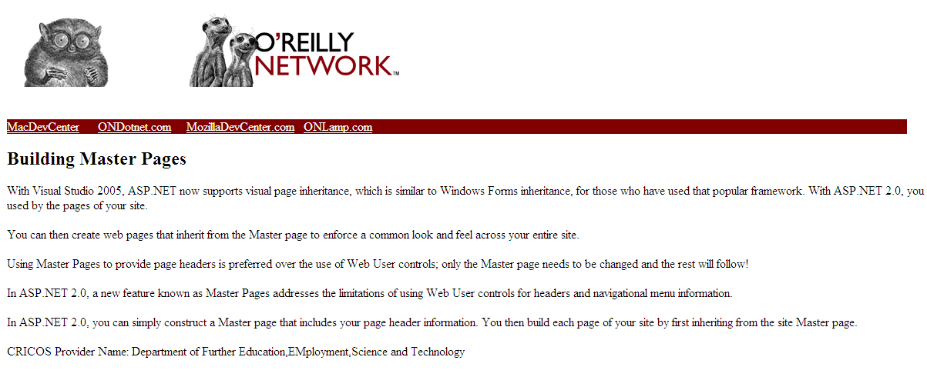
Figure 2-10: Displaying the Content page in Internet Explorer

Recall that the Master page contains a ContentPlaceHolder control. You can place content in the ContentPlaceHolder control in the Master page if you want to. If you do so, however, the content within ContentPlaceHolder will appear in the Content page when the page is loaded, unless the Content page overrides it by populating its own Content control.

What just happened?
What you have created is a Web Form (Default2.aspx) that inherits from a Master page (MasterPage.master). The beauty of a Master page is that you can create the content of a page template once and other Web Forms can then inherit from it. If the content of a Master page is changed, those changes will automatically show up in any page that inherits from it.

What about...
...converting an existing web page to a Content page?
When you look at the source of a normal Web Form (one that does not use a Master page), you will notice that it contains the usual bits of HTML you expect to find on an ASP.NET page as well as a <form> element:
<%@ Page Language="C#" AutoEventWireup="false" CodeFile="Default.aspx.cs"
Inherits="Default_aspx" %>

<!DOCTYPE html PUBLIC "-//W3C//DTD XHTML 1.1//EN" "http://www.w3.org/TR/xhtml11/
DTD/xhtml11.dtd">

<html xmlns="http://www.w3.org/1999/xhtml" >
<head runat="server">
<title>Untitled Page</title>
</head>
<body>
<form id="form1" runat="server">
<div>

</div>
</form>
</body>
</html>

However, a Content page does not contain the usual elements that make up an ASP.NET page (such as <html>, <body>, or <form>). Instead, you'll see an <asp:Content> element, which represents the Content control and its properties. The <asp:Content> control encapsulates whatever controls (and contents) you drop onto the Content's control.
<%@ Page Language="C#" MasterPageFile="~/MasterPage.master"
AutoEventWireup="false" CodeFile="Default.aspx.cs"
Inherits="Default_aspx" title="Untitled Page"
%>
<asp:Content ID="Content1" ContentPlaceHolderID="ContentPlaceHolder1" Runat="Server">
...
...
</asp:Content>
To convert a Web Form to a Content page, you simply need to add the MasterPageFile attribute to its Page directive and then remove all other HTML elements from the page. Here's a sample Page directive that does the job:
<%@ Page Language="C#" MasterPageFile="~/MasterPage.master"
AutoEventWireup="false" CodeFile="Default.aspx.cs"
Inherits="Default_aspx" %>
The Page directive simply converts the Default.aspx page of this lab to a Content page. What about the Content control, which is needed to display the content unique to the page? You can add it in code, like this:
<%@ Page Language="C#" MasterPageFile="~/MasterPage.master"
AutoEventWireup="false" CodeFile="Default.aspx.cs"
Inherits="Default_aspx" %>

<asp:Content ID="Content1" ContentPlaceHolderID="ContentPlaceHolder1"
runat="server">
</asp:Content>

If you don't specify the Content control in code, you will still see the Content control in Design View. You will be unable to add controls to the Content control unless you click on the Create Custom Content link in the Content Tasks menu of the Content control.

...applying a Master page to an entire site?
To require that all pages at a site use a particular Master page by default, just add the <pages> element to the Web.config file for the site:
<system.web>
<pages masterPageFile="MasterPage.master" />
...
A page that does not specify a value for the MasterPageFile attribute in its Page directive will use the MasterPage.master Master page by default. To override the default Master page setting in Web.config, simply add the MasterPageFile attribute to the Page directive of the web page in question and assign it the name of another file.

Lab 03
Modify a Master Page at Runtime

You can flexibly modify the content of the Master page so that it suits the theme of the page.
When a Web Form that uses a Master page is loaded at runtime, it displays the content of the Master page together with its own content. However, there are times when you will want to modify parts of the Master page when a particular web page is loaded. For example, at the O'Reilly Network site (http://www.oreillynet.com), pages that belong to the ONDotnet subsite display the ONDotnet logo (a leaping dolphin) in their headers, rather than the generic O'Reilly Network logo (the ever-familiar tarsier). Pages at other subsites, such as Perl.com and ONLamp.com, do likewise.

How do I do that?
To see how a Master page can be modified on the fly, we'll add a page to our previous Lab.
This page will use MasterPage.master and change the image in the Master page from the O'Reilly Network logo to the ONDotnet logo when it is loaded.
- Using the project created in the previous lab, add a new Web Form (right-click the project name in Solution Explorer, select Add New Item..., and then select Web Form) and check the "Select master page" checkbox at the bottom of the dialog. Name the Web Form ONDotnet.aspx. Click Add.
- Select Masterpage.master as the Master page.
- Populate the ONDotnet.aspx Web Form with text by copying the text from the ONDotnetContent text file located at : \Sessions\s4\Lab Resources\Lab 04 , and pasting the text between the <asp:Content> </asp:Content> Tags.

- Switch to Source View and insert the MasterType directive after the Page directive. The MasterType directive allows you to indicate a strongly typed reference to the Master page so that you can programmatically access its content (such as its public properties and methods):
- <%@ Page Language="C#" MasterPageFile="~/MasterPage.master"
- AutoEventWireup="false" CodeFile="ONDotnet.aspx.cs"
- Inherits="ONDotnet_aspx" title="Untitled Page" %>
- <%@ MasterType VirtualPath="~/MasterPage.master" %>
...
- In the code-behind of the Master page (MasterPage.master.cs), insert the public setLinkColor( ) method. By adding this public method to the Master page, Content pages will be able to programmatically set the color of the various LinkButton controls:

(you will need to import the System.Drawing package to use the Color class)
public void setLinkColor(String ctrl, Color lnkColor)
{
switch (ctrl)
{
case "MacDevCenter":
lnkMacDevCenter.ForeColor = lnkColor;
break;

case "ONDotnet":
lnkONDotnet.ForeColor = lnkColor;
break;

case "MozillaDevCenter":
lnkMozilla.ForeColor = lnkColor;
break;

case "ONLamp":
lnkONLamp.ForeColor = lnkColor;
break;
}

}
You need to use the Public access modifier on the setLinkColor( ) method, or else the Content page will not be able to call it.
- In the code-behind of ONDotnet.aspx (ONDotnet.aspx.cs), code the following Page_Load event:
protected void Page_Load(object sender, EventArgs e)
{
Master.setLinkColor("ONDotnet", System.Drawing.Color.Yellow);
Master.Page.Header.Title = "ONDotnet Page";

Image masterImage = (Image)Master.FindControl("imgTitle");
if (masterImage != null)
{
//masterImage.ImageUrl = "Images/ondotnet_logo.gif";

}

}
Essentially, you use the Master property to get a reference to the Master page. You first change the color of the ONDotnet.com LinkButton control by invoking the setLinkColor( ) method. You then change the title of the page by using the Master.Page.Header.Title property. Finally, you change the image of the logo in the Master page by using the FindControl( ) method.
Master is a special property exposed by the Web Form as a handler to access the Master page. In fact, every page can access the Master property; however it makes sense only if a page uses a Master page.
Press F5 to test the application. First load Default2.aspx and then click the ONDotnet.com link to load ONDotnet.aspx.

What just happened?
There are two ways you can modify the content of a Master page during runtime:
- Calling the public methods and setting the public properties of the Master page
- Using the FindControl( ) method (of the Master property) to locate controls on the page, and then calling the methods and setting the properties of those controls
The Master property is valid only on pages that reference a Master page in the MasterPageFile attribute in the Page directive. If you access the Master property on a page that does not reference a master page, a NullReferenceException is thrown.
Where possible, you should use the first method, which exposes the public methods and properties of the Master page. This approach is a much more efficient way to change controls on a Master page because it uses early binding, and therefore the controls are strongly typed.
To use early binding, the Master page needs to expose its public methods and properties (as in Step 5) so that a Content page can set or access them during runtime. In this lab you have exposed a public method called setLinkColor( ) in the MasterPage.master page. To change the color of a LinkButton in the Master page during runtime, you can call the setLinkColor( ) method in the Page_Load event of a Content page.
Use early binding whenever possible; it makes your development much easier and less error-prone.
With the second method, you locate the controls you want to modify on the Master page by using the FindControl( ) method of the Master property, then supplying the name and type of the control you want to modify. Once the control is located, you can change its properties as if it were a local object, as demonstrated in the following code fragment, which locates an image control on the Master page and substitutes a new .gif file containing the ONDotnet logo.

Image masterImage = (Image)Master.FindControl("imgTitle");
if (masterImage != null)
{
//masterImage.ImageUrl = "Images/ondotnet_logo.gif";

}
This technique uses late binding to access controls on a Master page because you need to explicitly convert the controls you find during runtime to the type that you want.
The FindControl( ) method uses late binding, while using public properties has the advantage of early binding and hence is strongly typed.

What about...
...accessing controls that are dynamically created when the Master page loads?
For example, a Master page may display additional late-breaking news by dynamically creating Label controls. The number of new controls generated may vary depending on the urgency of the news.
The advantage of making methods and properties public on a Master page is that you can use early binding, which means you can use IntelliSense to help you with their names and you can rely on the compiler to check their types at compile time.
However, if there are controls that will be created dynamically in the Master page during runtime, exposing public properties is no longer a viable option, since you need to decide what methods and properties to expose at design time.

Exercise
Using the web pages you created in Lab 01 , Create an appropriate Master Page that includes a series of LinkButton controls with the names of states and a link for the main page.
Each of the pages will encapsulate the MasterPage and the link color would change to indicate which page the user is currently viewing. For example if the user is on the Main page the Main link on the maseter page must change color.

Lab 04
Modify a Master Page at Runtime

You can flexibly modify the content of the Master page so that it suits the theme of the page.
When a Web Form that uses a Master page is loaded at runtime, it displays the content of the Master page together with its own content. However, there are times when you will want to modify parts of the Master page when a particular web page is loaded. For example, at the O'Reilly Network site (http://www.oreillynet.com), pages that belong to the ONDotnet subsite display the ONDotnet logo (a leaping dolphin) in their headers, rather than the generic O'Reilly Network logo (the ever-familiar tarsier). Pages at other subsites, such as Perl.com and ONLamp.com, do likewise.

How do I do that?
To see how a Master page can be modified on the fly, we'll add a page to our Lab 03
This page will use MasterPage.master and change the image in the Master page from the O'Reilly Network logo to the ONDotnet logo when it is loaded.
- Using the project created in the previous lab, add a new Web Form (right-click the project name in Solution Explorer, select Add New Item..., and then select Web Form) and check the "Select master page" checkbox at the bottom of the dialog. Name the Web Form ONDotnet.aspx. Click Add.
- Select Masterpage.master as the Master page.
- Populate the ONDotnet.aspx Web Form with text by copying the text from the ONDotnetContent text file located at: Session4\Lab Resources\Lab 04 (downloaded from Moodle) , and pasting the text between the <asp:Content> </asp:Content> Tags.

- Switch to Source View and insert the MasterType directive after the Page directive. The MasterType directive allows you to indicate a strongly typed reference to the Master page so that you can programmatically access its content (such as its public properties and methods):
<%@ Page Language="C#" MasterPageFile="~/MasterPage.master"
AutoEventWireup="false" CodeFile="ONDotnet.aspx.cs"
Inherits="ONDotnet_aspx" title="Untitled Page" %>
<%@ MasterType VirtualPath="~/MasterPage.master" %>
...
- In the code-behind of the Master page (MasterPage.master.cs), insert the public setLinkColor( ) method. By adding this public method to the Master page, Content pages will be able to programmatically set the color of the various LinkButton controls:
(you will need to import the System.Drawing package to use the Color class)
public void setLinkColor(String ctrl, Color lnkColor)
{
switch (ctrl)
{
case "MacDevCenter":
lnkMacDevCenter.ForeColor = lnkColor;
break;

case "ONDotnet":
lnkONDotnet.ForeColor = lnkColor;
break;

case "MozillaDevCenter":
lnkMozilla.ForeColor = lnkColor;
break;

case "ONLamp":
lnkONLamp.ForeColor = lnkColor;
break;
}

}
You need to use the Public access modifier on the setLinkColor( ) method, or else the Content page will not be able to call it.
- In the code-behind of ONDotnet.aspx (ONDotnet.aspx.cs), code the following Page_Load event:
protected void Page_Load(object sender, EventArgs e)
{
Master.setLinkColor("ONDotnet", System.Drawing.Color.Yellow);
Master.Page.Header.Title = "ONDotnet Page";

}
Essentially, you use the Master property to get a reference to the Master page. You first change the color of the ONDotnet.com LinkButton control by invoking the setLinkColor( ) method. You then change the title of the page by using the Master.Page.Header.Title property. Finally, you change the image of the logo in the Master page by using the FindControl( ) method.
Master is a special property exposed by the Web Form as a handler to access the Master page. In fact, every page can access the Master property; however it makes sense only if a page uses a Master page.
Press F5 to test the application. First load Default2.aspx and then click the ONDotnet.com link to load ONDotnet.aspx.
What just happened?
There are two ways you can modify the content of a Master page during runtime:
- Calling the public methods and setting the public properties of the Master page
- Using the FindControl( ) method (of the Master property) to locate controls on the page, and then calling the methods and setting the properties of those controls
The Master property is valid only on pages that reference a Master page in the MasterPageFile attribute in the Page directive. If you access the Master property on a page that does not reference a master page, a NullReferenceException is thrown.
Where possible, you should use the first method, which exposes the public methods and properties of the Master page. This approach is a much more efficient way to change controls on a Master page because it uses early binding, and therefore the controls are strongly typed.
To use early binding, the Master page needs to expose its public methods and properties (as in Step 5) so that a Content page can set or access them during runtime. In this lab you have exposed a public method called setLinkColor( ) in the MasterPage.master page. To change the color of a LinkButton in the Master page during runtime, you can call the setLinkColor( ) method in the Page_Load event of a Content page.
Use early binding whenever possible; it makes your development much easier and less error-prone.
With the second method, you locate the controls you want to modify on the Master page by using the FindControl( ) method of the Master property, then supplying the name and type of the control you want to modify. Once the control is located, you can change its properties as if it were a local object, as demonstrated in the following code fragment, which locates an image control on the Master page and substitutes a new .gif file containing the ONDotnet logo.

Image masterImage = (Image)Master.FindControl("imgTitle");
if (masterImage != null)
{
masterImage.ImageUrl = "Images/ondotnet_logo.gif";

}
This technique uses late binding to access controls on a Master page because you need to explicitly convert the controls you find during runtime to the type that you want.
The FindControl( ) method uses late binding, while using public properties has the advantage of early binding and hence is strongly typed.

What about...
...accessing controls that are dynamically created when the Master page loads?
For example, a Master page may display additional late-breaking news by dynamically creating Label controls. The number of new controls generated may vary depending on the urgency of the news.
The advantage of making methods and properties public on a Master page is that you can use early binding, which means you can use IntelliSense to help you with their names and you can rely on the compiler to check their types at compile time.
However, if there are controls that will be created dynamically in the Master page during runtime, exposing public properties is no longer a viable option, since you need to decide what methods and properties to expose at design time.

Additional Exercise
Using the web pages you created in Lab 04 , Create an appropriate Master Page that includes a series of LinkButton controls with the names of states and a link for the main page.
Each of the pages will encapsulate the MasterPage and the link color would change to indicate which page the user is currently viewing. For example if the user is on the Main page the Main link on the master page must change color.

